Auto Ticket Classification using Flow Designer
Screenshot 1 — Navigation Search:
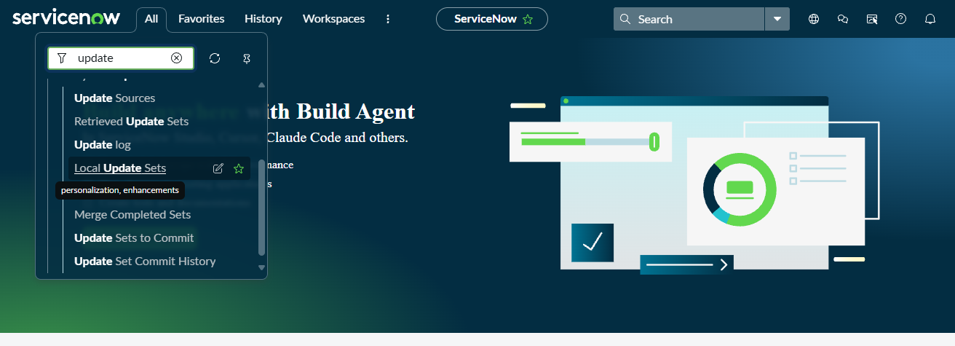
Screenshot 2 — Local Update Sets List:
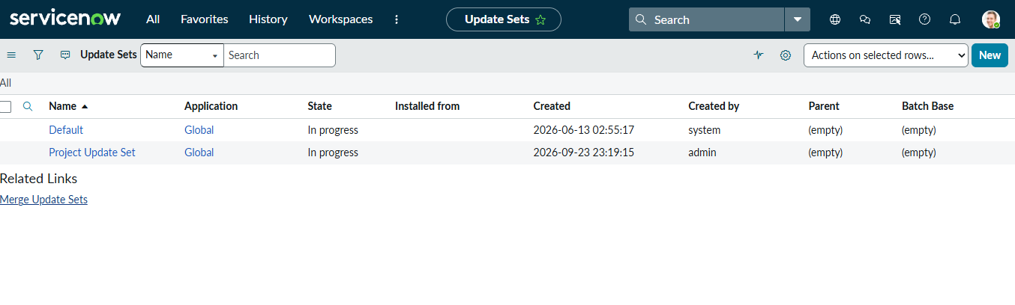
Screenshot 3 — Your Created Update Set Details:
